The Effect of Counter-Stereotypical Partisan Exemplars on Partisan Stereotypes and Affective Polarization

C. Daniel Myers
University of Minnesota
cdmyers@umn.edu

12/31/2019

Draft prepared for the 2020 Meeting of the Southern Political Science Association

Abstract:

An extensive literature in psychology and communications documents the effect of stereotypical and counter-stereotypical exemplars, individual members of a group presented in a way that casts them as representative of that group, on inter-group attitudes and beliefs. We build on this work by examining the effect of partisan exemplars on attitudes and beliefs about out-partisans. We present experimental subjects with either ideologically stereotypical or ideologically counter-stereotypical exemplars of the party they do not identify with. We evaluate the effect of these exemplars on stereotypes of and affect towards out-partisans. The results suggest that counter-stereotypical exemplars can moderate stereotypes of partisan ideology and improve affect towards the out-party. These results have important implications for understanding how the media shape partisan stereotypes, and also suggest methods for reducing inter-partisan animosity.

The dominant trend in American politics over the last several decades has been the rise in what political scientists refer to as affective polarization, the mutual “fear and loathing” that contemporary partisans feel for each other (Iyengar et al. 2012, Iyengar and Westwood 2015, Mason 2018). Americans are no more ideologically polarized than they were in the 1950s and 60s – that is, they do not hold more extreme issue positions (Fiorina et al. 2008, 2011). Yet they dislike and distrust each other more than at any time in modern American history (Iyengar et al. 2012, Mason 2018). One potential driver of this trend is distorted mental representations of the out-party. These “pictures in our heads” (Lippman 1922) – the stereotypes we hold about the out-party – cast the out-party as more demographically “other” (Ahler and Sood 2018, Mason and Wronski 2018, Valentino and Zhirkov 2019), and more ideologically extreme (Rothschild 2019, Myers 2020), than they really are.
How did we arrive at these distorted images of the out-partisans? A theoretical and empirical literature suggests that these images are built from group exemplars, salient example of a group member who are seen as representative of that group. Some prominent theories of stereotype representation argue that stereotypes of groups consist of stores of exemplary individual group members (Kahneman and Miller 1986, Smith and Zarate 1992, Garcia-Marques et al. 2006), encountered either in person or, especially for out-groups with whom we have little personal experience, through the media (Entman and Rojecki 2000). Experimental research reinforces this by showing that exposure to new exemplars, particularly counter-stereotypical exemplars, can change inter-group attitudes and stereotypes (Dasgupta and Greenwald 2001, Mastro and Tukachinsky 2011). Much of this empirical literature has focused on the effect of stereotypical and counter-stereotypical racial exemplars on racial attitudes and stereotypes, but it may offer an explanation for deteriorating out-party attitudes and stereotypes as well.
We test this possibility by testing whether exposure to counter-stereotypical out-party exemplars can change out-party stereotypes and improve affect towards the out-party. We focus, in particular, on ideological stereotypes of the two parties. Existing work shows that partisans perceive more ideological polarization than actually exists (Levendusky and Malhotra 2016a), that these misperceptions drive affective polarization (Levendusky and Malhotra 2016a, Ahler and Sood 2018), and that these misperceptions may be driven by the presentation of extreme exemplars in the media (Levendusky and Malhotra 2016b). Moreover, recent work suggests that ideology and issue-positions, rather than group identities, form the core part of partisan stereotypes (Rothschild et al. 2019, Myers 2019). If exposure to out-group exemplars drive inter-group attitudes and stereotypes, we expect that exposure to ideologically counter-stereotypical (that is, ideologically moderate) exemplars of the out-party should reduce ideological stereotyping and improve affect towards the out-party, relative to exposure to ideologically stereotypical exemplars.
We test these hypotheses using an experiment where respondents are exposed to descriptions of four sitting members of Congress from the out-party. We manipulate whether participants are exposed to four ideologically stereotypical out-party members or of one ideologically stereotypical and three ideologically moderate out-party members. Members of Congress are useful as exemplars because they are clearly group members and frequently appear in media accounts as exemplars of their parties. Their official position reduces the chance that they will be seen as artificial or unrealistic by subjects, as might be the case with hypothetical or fake candidates. Further, they have concrete records that can be used to characterize them as either stereotypical or counter-stereotypical, yet are, for the most part, not sufficiently well-known for people to have concrete negative or positive attitudes towards them. After exposure, we measure out-party affect, perceptions of out-party extremity, and implicit affect towards the out-party. We find general support for this theory, finding that experimental participants exposed to moderate exemplars have more moderate perceptions of out-group ideology and more positive affect towards the out-party than participants exposed to ideologically typical exemplars.

Exemplification Theory and Counter-Stereotypical Exemplars
Stereotypes play an important role in social and political judgement, guiding attitudes and behavior towards out-group members. Exemplification theory holds that these stereotypes are constructed from the stream of exemplary individuals from that group encountered either in person or via the media (Smith and Zárate 1992, Brosius 2003, Garcia-Marques et al. 2006). According to this theory, stereotypes are not fixed mental objects, but instead are constructed as needed by retrieving from memory a set of exemplary individual members of the group (Kahneman and Miller 1986, Garcia-Marques et al. 2017). For many out-groups mediated contact is far more common than actual in-person contact, so the stored set of exemplary individuals come to mirror the (often inaccurate) exemplars that dominate media coverage of a group (Entman and Rojecki 2000). Thus, for example, stereotypes associating blacks with criminality and government dependence are produced and reproduced by media coverage that rarely includes example of blacks as anything other than welfare recipients and violent criminals (Gilens 1997, Entman and Rojecki 2000). These stereotypes, in turn, drive affect and attitudes towards the out-group.
Exemplification theory’s focus on the store of group exemplars as the determinant of group stereotypes suggests that providing counter-stereotypical exemplars can change the content of an out-group stereotype, and with it out-group affect and attitudes. Indeed, a range of studies in psychology demonstrate that this is the case. Dasgupta and Greenwald (2001) introduce this paradigm in an experiment that exposes subjects to liked black exemplars (e.g. Martin Luther King) and disliked white exemplars (e.g. Jeffrey Dahmer), or disliked black exemplars (e.g. Mike Tyson) and liked white exemplars (e.g. Tom Hanks) and found a large positive effect of the liked-black/disliked-white condition on implicit, though not explicit, racial attitudes. This effect was replicated with implicit attitudes towards the elderly (Dasgupta and Greenwald 2001, Study 2), women leaders (Dasgupta and Asgari 2004), and gays and lesbians (Dasgupta and Rivera 2008). In high-powered replication studies, Joy-Gaba and Nosek (2010) and Pinkston (2015) replicate the positive effect on out-group implicit attitudes, though they find much small effect sizes that reported in the original Dasgupta and Greenwald study. Finally, a series of laboratory experiments suggest that exposure to Barack Obama has a positive effect on white implicit attitudes and stereotypes (see Columb and Plant 2016 for a review, cf. Schmidt and Nosek 2010, Schmidt and Axt 2016).
Research in communication extends this finding to stereotypes and explicit attitudes. Mastro and Tukachinsky (2011) find that exposure to a well-liked Latino exemplar (the actor Jimmy Smits) improved stereotypes of Latinos, at least among those with positive attitudes towards intergroup racial conduct. Further studies find that exposure to other well-liked minority celebrities reduced negative stereotypes of blacks (Ramasubramanian 2011, 2015), and improved affect towards Latinos and Asians (Mares Forthcoming). Other work finds that counter-stereotypical news portrayals of racial minorities improved implicit stereotypes (Ramasubramanian 2007), explicit affect (Ramasubramanian and Oliver 2007), and led to more external attributions of responsibility (Power et al. 1996).
Relatively little work has examined the effect of exemplar exposure outside of the laboratory, though Tukachinsky et al. (2015) document a correlation between racial attitudes and portrayals of racial minorities in primetime television, and Dixon (2008) connects the content of local news to stereotypes of blacks as criminals (see also Valentino 1999). One important exception to this is work by Goldman and co-authors on the so-called “Obama effect” (Goldman 2012, Goldman and Mutz 2014, Goldman and Hopkins 2019). Goldman argues that Obama’s prominent depiction in the media as a black exemplar who was counter-stereotypical in many ways to the relentlessly negative exemplars usually presented in the media (Entman and Rojecki 2000) caused a radical change in the stream of black exemplars encountered by whites during the 2008 and 2012 presidential campaigns. They find that this change reduced white racial prejudice during these campaigns. However, this change appears to have only lasted for the duration of the campaign (Goldman and Mutz 2014, Pasek et al. 2014), after which the stream of black exemplars returned to its normal state. Kerevel and Atkenson (2015) report a similar pattern of findings when examining the effect of female mayors in Mexico on stereotypes about gender and leadership.
Despite growing scholarly interest in and concern about affective polarization (Iyengar et al. 2019) almost no work examines the effect of partisan exemplars on partisan stereotypes and affect. Instead, most work examining the role of the media in affective polarization focuses on the partisan slant of outlets. Conventional wisdom and some studies argue that access to and consumption of partisan media drives polarization by providing biased information and promoting norms of hostility towards the out-party (Levendusky 2013, Berry and Sobieraj 2014, Lelkes et al. 2017). However, this claim is highly contested. Other work argues that partisan media is mostly consumed by those who are already polarized (Arceneaux and Johnson 2013), that audiences for partisan media are small (Prior 2013), and finally that, in practice, most Americans consumer a politically diverse news diet if they consume news at all (Gentzkow and Shapiro 2011, Prior 2013).
The extensive literature on racial exemplars suggests an alternative way that media might influence affective polarization. Since most contact with members of the other party, particularly elite members of the other party, is mediated, stereotypes of the two parties will be created by the stream of partisan exemplars presented in the media. Changes in these streams of exemplars will change stereotypes, at least as long as the change in exemplars lasts. Durable changes in the stream of exemplars, caused, for example, by increased elite polarization (Mutz 2007, pgs. 238-240), will cause durable changes in how Americans view the two parties. This theory depends, however, on exemplars having the power to shape partisan stereotypes.
One existing study touches on the effect of partisan exemplars on affective polarization. First, as part of a larger study examining the effect of media coverage of polarization, Levendusky and Malhotra (2016a) find that reading an article that depicts Americans as polarized and divided increases affective polarization relative to an article that depicts Americans as moderate and centrist. Both articles include quotes from average voters from both parties as exemplars to illustrate polarization or moderation. This effect cannot necessarily be attributed to the exemplars, as two articles differ in a number of ways beyond the presence of these quotes, but the authors report participants had more negative reactions to the polarized exemplars and viewed them as more representative of their party and suggest that these reactions could be a mechanism by which coverage of polarization drives increase polarization.
Hypotheses
To test whether partisan exemplars can shape ideological stereotypes of and affect towards the out-party, we conduct a conceptual replication of studies like Dasgupta and Greenwald (2001) and Mastro and Tuckachinsky (2011). Following this paradigm, we present individuals with four out-party exemplars, operationalized here as members of Congress. These exemplars are either ideologically stereotypical (i.e. conservative Republicans and liberal Democrats) or counter-stereotypical (i.e. moderate Republicans and Democrats). We then measure out-party affect, perceptions of out-party ideology, and implicit attitudes towards the out-party. This design and hypotheses were pre-registered prior to conducting the experiment (https://osf.io/p2g6s).
In this paper we test two sets of hypotheses. First, we expect that participants presented with counter-stereotypical exemplars will have more moderate perceptions of out-party ideology, relative to participants presented with stereotypical exemplars. Further, we expect that this effect will be primarily driven by participants in the counter-stereotypical exemplar condition moderating their perceptions, rather than participants in the stereotypical exemplar condition developing more extreme perceptions, because the stereotypical exemplars will be similar to the stream of exemplars commonly encountered in the media.

H1a: Democratic Perceptions of Republican Ideology:
- Democrats in the Moderate Republican condition will report more moderate perceptions of Republican ideology than Democrats in the Conservative Republican condition.
- This effect will be the result of Democrats in the Moderate Republican Exemplar condition having more moderate perceptions than Democrats in the control condition, not Democrats in the Conservative Republican condition having more extreme perceptions than Democrats in the control condition.

H1b: Republican Perceptions of Democratic Ideology:
- Republicans in the Moderate Democrat condition will report more moderate perceptions of Democratic ideology than Republicans in the Liberal Democrat condition.
- This effect will be the result of Republicans in the Moderate Democrat Exemplar condition having more moderate perceptions than Republicans in the control condition, not Republicans in the Liberal Democrat condition having more extreme perceptions than Republicans in the control condition.

Second, we expect that being presented with counter-stereotypical exemplars of the out-party will reduce negative affect towards the out-party, and that this effect will be driven by counter-stereotypical exemplars improving out-party affect relative to the control condition, not by stereotypical exemplars reducing affect towards the out-party.

H2a: Democratic Affect towards Republicans
- Democrats in the Moderate Republican Exemplar condition will display more positive affect towards Republicans than will Democrats in the Conservative Republican Exemplar condition.
- This effect will be the result of Democrats in the Moderate Republican Exemplar condition displaying more positive affect towards Republicans than Democrats in the control condition, not of Democrats in the Conservative Republican condition displaying more positive affect than Democrats in the control condition.

H2b: Republican Affect towards Democrats
- Republicans in the Moderate Democrat Exemplar condition will display more positive affect towards Democrats than will Republicans in the Liberal Democrat Exemplar condition.
- This effect will be the result of Republicans in the Moderate Democrats Exemplar condition displaying more positive affect towards Democrats than Republicans in the control condition, not of Republicans in the Liberal Democrat condition displaying more positive affect than Republicans in the control condition.
Method
Pre-Test of Exemplars
To ensure that the presented exemplars are perceived as ideologically moderate or extreme, we conducted a pre-test using respondents from Lucid’s Theorem platform. We drafted profiles of ten moderate Democrats, ten liberal Democrats, ten moderate Republicans, and ten Conservative Republicans. We selected these potential exemplars based on a number of factors, including their DW-Nominate scores (Lewis et al. 2019), positions on high-profile issues, membership in ideological caucuses like the Blue Dog Democrats or the House Freedom Caucus, as well as our general perception of their positions and media images.
Each profile was 100-150 words long and included the member’s official portrait. While the content of each profile was tailored to the member, each followed the same general form. The first sentence introduced the member and where they represented. The second provided a brief biographical history, including when they were elected and notable previously held offices or other careers highlights. The next several sentences described notable positions (e.g. “a supporter of abortion rights”), bill authorship or sponsorship (e.g. “is the author of the College for All Act, which would eliminate tuition and fees at public colleges across the United States”), votes (e.g. “was the only House Democrat from Illinois to vote against the Affordable Care Act”), or other signals of ideological stances (e.g. “is a member of the Main Street Caucus, a group of moderate Republicans in Congress,” or “is seen as one of Donald Trump’s biggest supporters in Congress”). A final sentence sometimes noted personal characteristics that might signal ideology or representativeness of the exemplar (e.g. “is one of only 14 naturalized citizens serving in Congress.”) All these descriptors were selected to portray the member as describe generally stereotypical or counter-stereotypical ideologically in as natural a way as possible.
We pre-tested these 40 profiles using a sample of 162 respondents drawn from Lucid Theorem’s online platform. Respondents were asked to read each profile and then rate the ideology of the profiled member of Congress, guess their position on four issues (taxes, immigration, abortion, and government intervention into healthcare markets), rate how representative they were of their party as a whole, and rate how positively or negatively they viewed the member. Each respondent rated the potential exemplars from one party only. The results of the pre-test are listed in the appendix, with the selected exemplars listed at the top of each category. As counter-stereotypical exemplars, we selected the three exemplars that were rated as (relatively) moderate, as well as being rated as at least moderately representative of their party as a whole. As stereotypical exemplars, we chose the exemplars that were rated as moderately conservative for Republicans and fairly liberal for Democrats, relative to the other exemplars, and as moderately representative of their party as a whole, again relative to the other exemplars. Importantly, we rely on the pre-test measures of perceived ideology and representativeness to choose exemplars that are the most stereotypical or counter-stereotypical. This does not allow us to determine which aspects of the profile (e.g. policy stances, caucus membership, demographic characteristics communicated in the member’s official portrait), caused respondents to view them as stereotypical or counter-stereotypical.

Experimental Procedure
We recruited 3,167 respondents over the Lucid Theorem platform to participate in an academic research study of people’s opinions. Democrats and Republicans were assigned to different branches of the experiment, and true independents were divided equally between these branches. Each participant was randomly assigned to one of three conditions: a control condition, a Moderate Out-Partisan Exemplar condition or a Conservative/Liberal Out-Partisan Exemplar condition. To reduce variance and facilitate the calculation of heterogeneous treatment effects, participants were assigned to experimental conditions using block randomization, blocking on strength of partisanship and a binary indicator of political interest split at the expected median,
Participants first answered two pre-treatment questions measuring interest in politics. After these, participants in non-control conditions were introduced to the treatment with the following instruction: “Thank you for taking part in this study of people's opinions about individual members of Congress. There are 435 members of Congress and we find that most people don't know much about members other than their own representatives. In this part of the study we will present you with four brief profiles of ordinary members of Congress. Please read each profile carefully. You've been selected to view randomly-selected, ordinary members the <Republican/Democratic> Party. After each profile, we will ask you two questions to get your thoughts about the member of Congress.”
Participants were then presented sequentially with four profiles. All Democrats (Republicans) read the same profile first, that of a conservative Republican (liberal Democrat). Those in the Moderate conditions then read profiles of three moderate Republicans/Democrats while those in the Liberal Democrat or Conservative Republican condition read profiles of three conservative Republicans or liberal Democrats. At the bottom of each profile two questions asked subjects how familiar they were with the member of Congress and how positive or negative they felt towards the member of Congress. These questions were intended to encourage participants to actively think about the exemplar in a way that would not encourage or discourage sub-typing by, for example, asking how liberal or conservative or how representative they perceived the exemplar to be.
Following these four profiles, participants completed measures of out-party affect and perceptions of the two parties’ ideologies, the order of which was counter-balanced. Respondents who were not using mobile devices then completed the partisan brief implicit attitude test. The complete survey can be seen at https://osf.io/ax52t/.

Measures
We use the measure of partisanship in Lucid’s demographic data, which uses a standard 7-point ANES format. We measure political interest using two items, which we used to create an additive index (Cronbach’s α = .87). After treatment, we measure perceptions of out-party ideology using two measures. First, we ask respondents to place the average Republican and average Democrat on a standard seven-point ideological scale. Second, following Levendusky and Malhotra (2016), we ask respondents to place the average Republican and the average Democrat on three issue position scales: capital gains taxes, deportation of immigrants who arrived as children, and abortion. We expected these three measures to produce an additive index, but because of low scale reliability (Cronbach’s α = .52 for Democrats’ issue positions, .53 for Republicans’ issue positions) we analyze these items separately.
We use three different measures of out-party affect, drawn from Druckman and Levendusky (2019). First, the out-party feeling thermometer, corrected for individual neutral point by subtracting the mean score of four other feeling thermometers (labor union, big business, feminists, Christian fundamentalists) as suggested by Winter and Berinsky (1999). Second, an index of two items measuring trust in each party (α = .90 for trust in Democrats, .89 for trust in Republicans). Third, an index of three social distance measures (α = .88 for social distance from Democrats, .89 for social distance from Republicans). We measure implicit attitudes using a version of the Partisan Brief Implicit Attitudes Test described in Iyengar and Westwood (2015) to measure implicit attitudes towards the out-party, implemented in Qualtrics using Carpenter et al. (2019)’s R package, and scored using the procedure recommended by Nosek et al. (2014).

Analysis
We analyze Republicans and Democrats separately. For both sub-samples, we evaluate hypotheses using difference in means tests, accounting for the experiment’s blocking scheme. We generate confidence intervals and p-values (one-sided, in the hypothesized direction) using randomization inference. For analyses comparing moderate to liberal/conservative conditions we drop inattentive respondents, defined as respondents who spend less than eight seconds on the initial profile. Since this profile was the same for moderate and conservative conditions, this provides a pre-treatment measure of respondent attentiveness. For hypotheses comparing a treatment condition to the control condition we cannot perform a similar calculation, since the control condition did not see any profiles. Instead, we calculate the Intent-to-Treat effect (ITT) using all subjects, and the Complier Average Causal Effect (CACE), treating respondents in the treatment condition who spent eight second or more on the first profile as compliers (Harden et al. 2019).

Results
For all results, we report the one-sided p-value in the hypothesized direction, as well as the standardized effect size (Cohen’s d), which is the difference in means divided by the pooled standard deviation. To provide a sense of the substantive scale of the effects, we also show the standardized difference on the outcome variable between all Democrats/Republicans (including leaners) in the sample and all true independents in the sample.
Exemplars and Perceptions of Out-Party Ideology
Figure 1 shows the first test of H1, the hypothesis that moderate exemplars will moderate stereotypes of out-party ideology by pushing perceptions of Democratic ideology in a conservative direction and perceptions of Republican ideology in a liberal direction. The top panel shows the effect of moderate Democratic exemplars on Republicans’ perceptions, as compared to liberal Democratic exemplars. We find statistically significant effects in the expected direction for perceived general ideology (p = .004, d = .18, d _{Reps/Inds} = .51), position on immigration (p = .002, d = .19, d _{Rep/Inds} = .53), and position on abortion (p = < .001, d = .26, d _{Reps/Inds} = .47); the effect on perceived position on taxes is in the expected direction but not statistically significant (p = .219, d = .05, d _{Reps/Inds} = .34). These effects are not large substantively, with d ranging from .05 to .19, but are substantively meaningful, equivalent to roughly one-third the size of the difference between true independents and Republicans in the full sample.
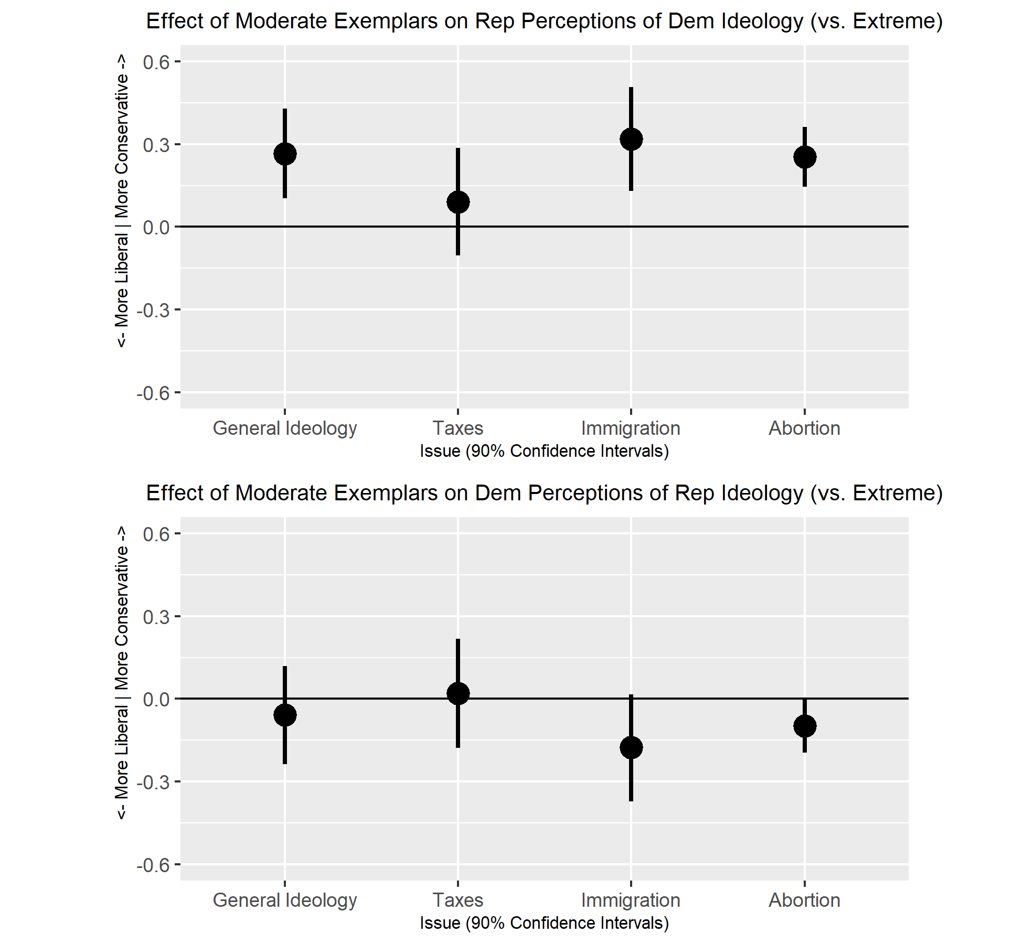
Figure 1: Effect of Moderate vs. Extreme Exemplars on Perceptions of Out-Party Ideology
The effect of moderate Republican exemplars on Democrats is less consistent (Figure 1b), though still primarily in the expected direction. The effect on perceived position on abortion statistically significant (p = .049, d = .10, d _{Dems/Inds} = .20), and the effect on perceived position on immigration marginally so (p = .067, d = .10, d _{Dems/Inds} = .27), but the effect on perceived general ideology not significant (p = .297, d = .03, d _{Dems/Inds} = .26) and the effect on perceived position on taxes in the wrong direction, though essentially zero (p = .559, d = .01, d _{Dems/Inds} = .13). While the size of the effects of moderate Republican exemplars on Democrats is smaller than the effect of moderate Democratic exemplars on Republicans, they are of a similar magnitude relative to the difference between true independents and Democrats in the full sample.
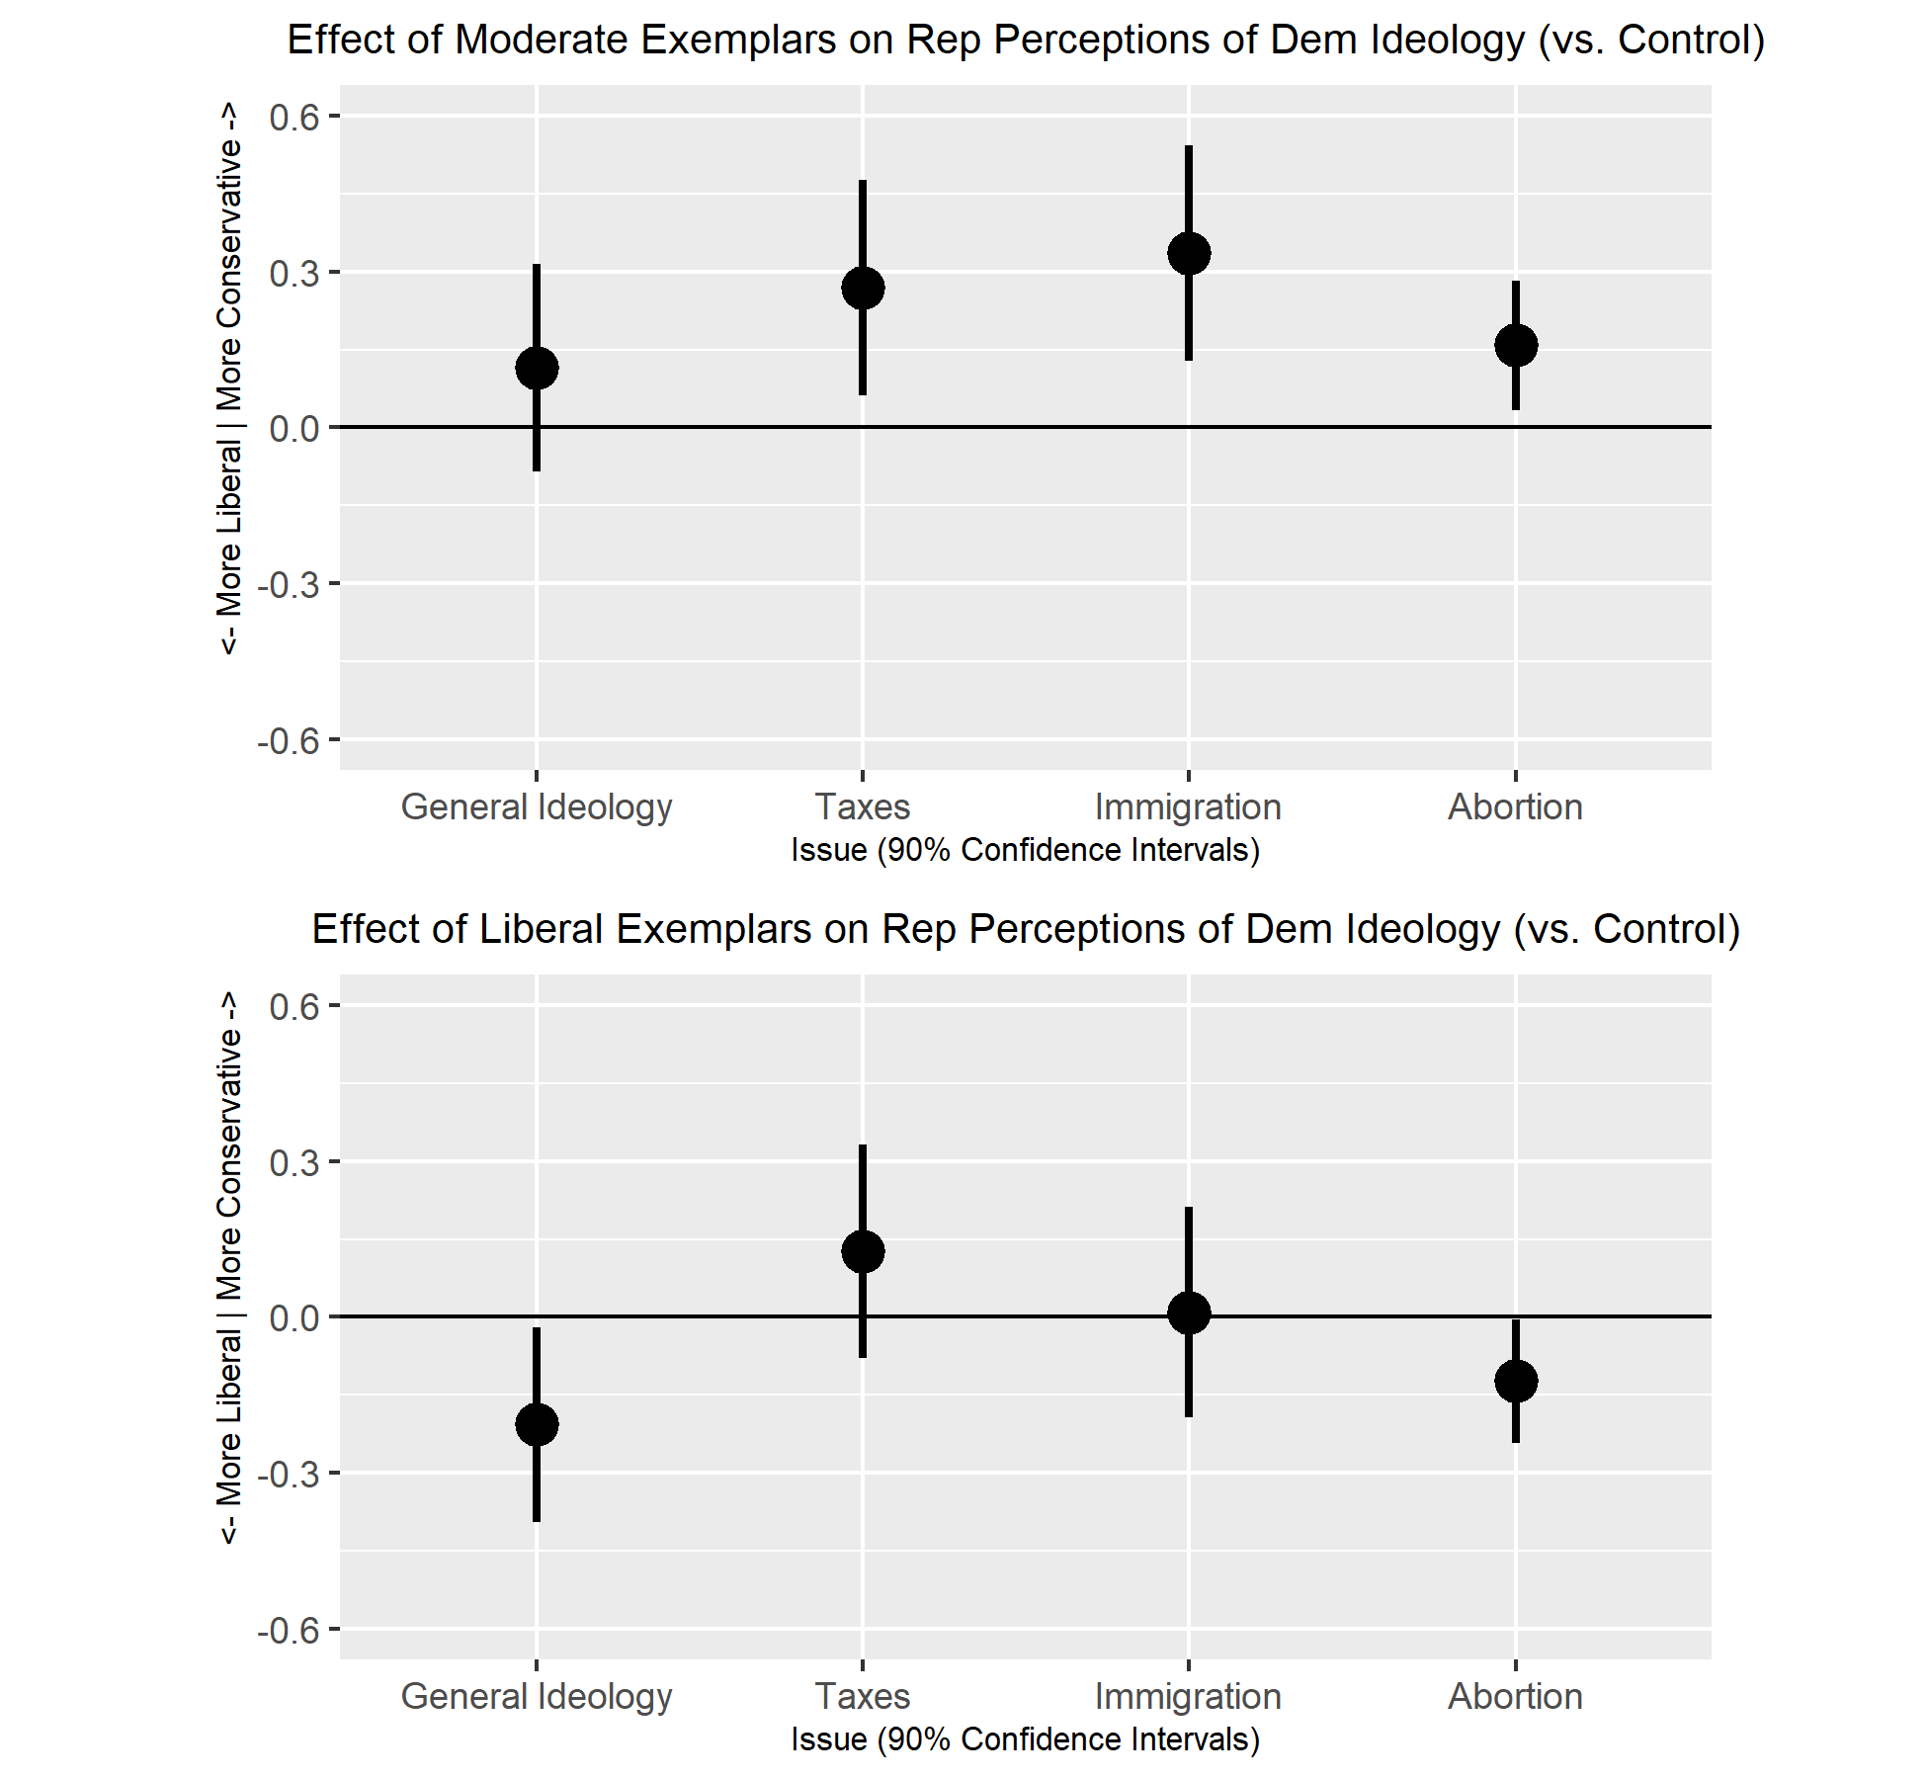
Figure 2: Effect of Dem Exemplars vs. Control on Rep Perceptions of Dem Ideology
On the whole, these results suggest that moderate exemplars can moderate perceptions of out party ideology, though the effects were larger for Republicans in our sample than for Democrats and for some issues (abortion and immigration) than others (general ideology and taxes). H1a1 and H1b1 posit that these effects will be the result of participants in the moderate exemplar conditions moderating their views of out-party ideology, not of participants in the conservative/liberal exemplar conditions growing to view the out-party as more extreme. To evaluate this, we compare both treatment conditions to the control condition. Figure 2 shows the CACE of moderate Democratic exemplars (Panel A) and liberal Democratic exemplars (Panel B) vs. the control condition. For all four issues the effect of moderate exemplars is in the expected direction, moving perceptions in a conservative direction, and the effect is statistically significant for taxes (p = .016, d = .16, d _{Reps/Inds} = .34), immigration (p = .004, d = .21, d _{Reps/Inds} = .54), and abortion (p = .018, d = .18, d _{Reps/Inds} = .48), though not general ideology (p = .171, d = .08, d _{Reps/Inds} = .51). Contrary to expectations, there is evidence of an effect of liberal exemplars moving perceptions of issue positions in a liberal direction on general ideology (p = .035, d = .15, d _{Reps/Inds} = .51) and abortion (p = .044, d = .14, d _{Reps/Inds} = .48), though the effect is negligible for immigration (p = .472, d = .01, d _{Reps/Inds} = .54), and in the opposite direction, though not statistically significant for taxes (p = .156, d = .08, d _{Reps/Inds} = .34).
The effect on Democratic perceptions of Republican ideology (Figure 3), is more mixed. Relative to the control condition, moderate Republican exemplars have a negligible effect on perceptions of Republicans’ general ideology (p = .374, d = .02, d _{Dems/Inds} = .26) and position on abortion (p = .433, d = .01, d _{Dems/Inds} = .20), and the opposite of the expected effect on perceived position on taxes (p = .046, d = .11, d _{Dems/Inds} = .13). Only for perceived position on immigration do moderate exemplars have the expected effect (p = .018, d = .14, d _{Dems/Inds} = .27). In contrast, the effect of conservative exemplars is largely in line with expectations, with negligible effects on perceptions of general ideology (p = .370, d = .02, d _{Dems/Inds} = .26), taxes (p = .266, d = .04, d _{Dems/Inds} = .13), and immigration (p = .067, d = .05, d _{Dems/Inds} = .27), while only the effect on abortion approaches statistical significance (p = .087, d = .10, d _{Dems/Inds} = .20).
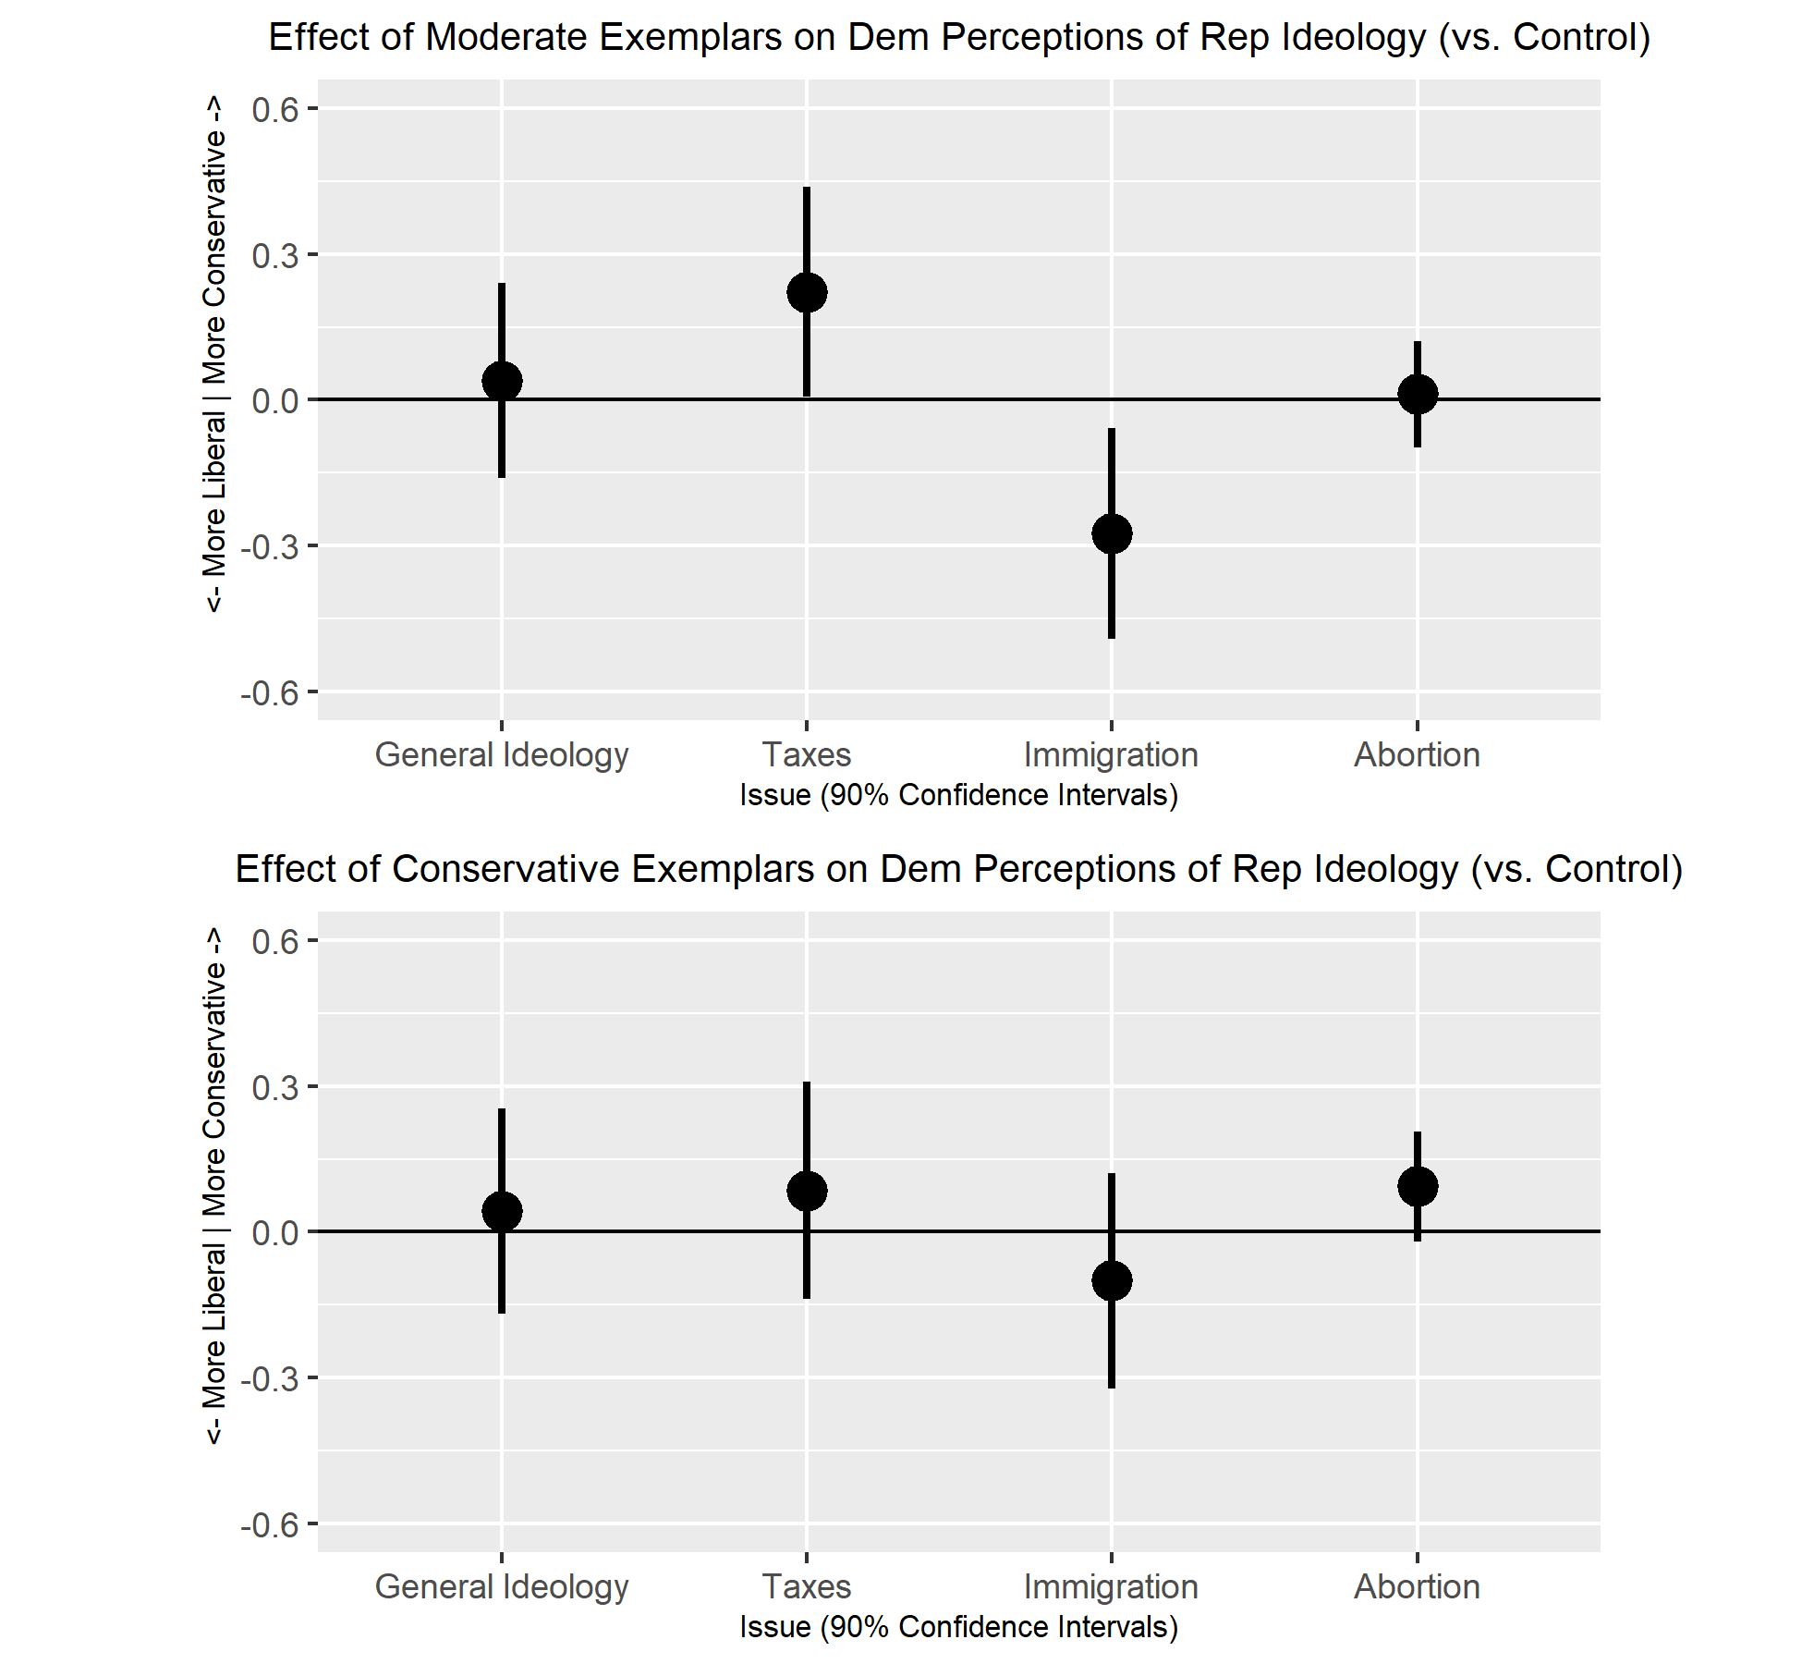
Figure 3: Effect of Rep Exemplars vs. Control on Dem Perceptions of Rep Ideology
In summary, the moderate exemplars treatment moderated perceptions of out-party ideology relative to the liberal/conservative exemplars condition, though the observed effect is larger and more consistent for Republicans than for Democrats, and for some issues (abortion, immigration), than others (taxes). There is some evidence that this effect is driven primarily by the effect of moderate exemplars moving perceptions of out-party ideology in a moderate direction, as opposed to ideological exemplars moving perceptions of out-party ideology in an ideologically stereotypical direction, though this evidence is weaker.
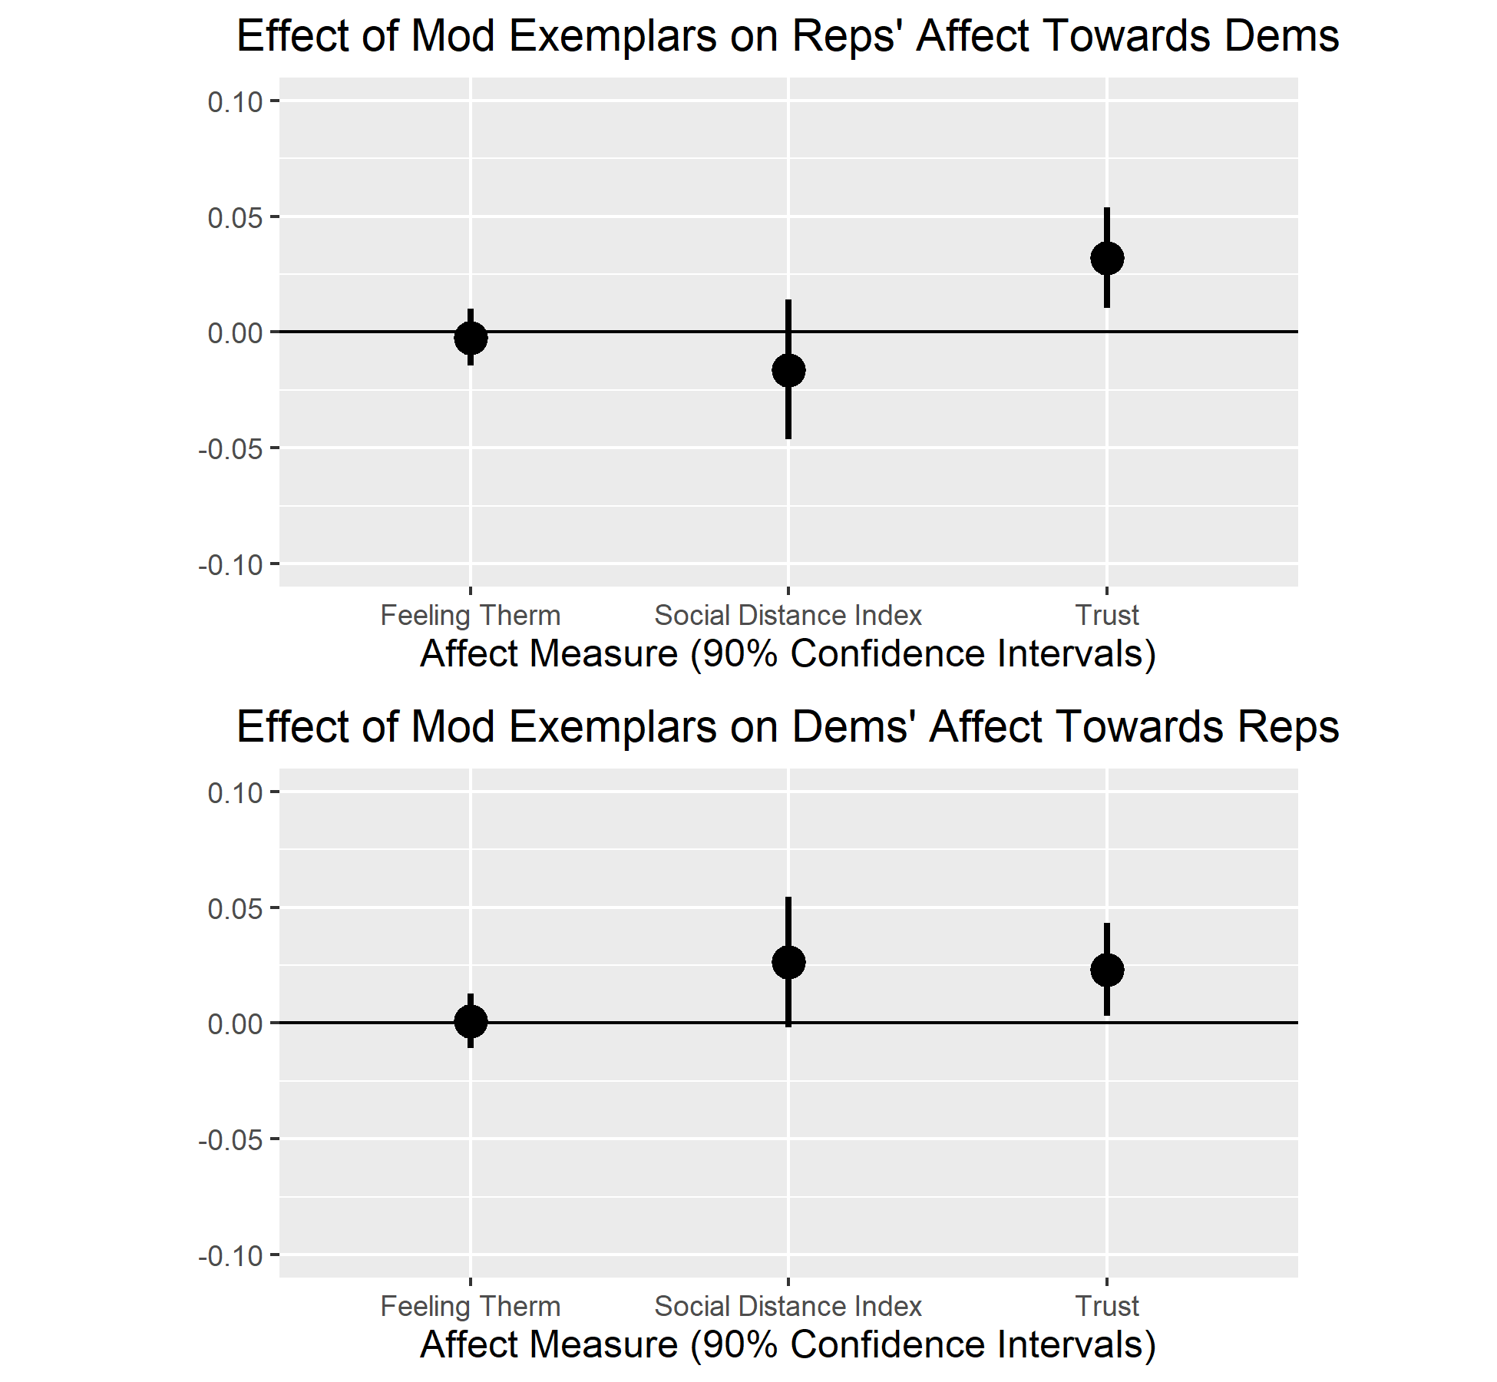
Figure 4: Effect of Moderate Exemplars vs. Extreme on Out-Party Affect

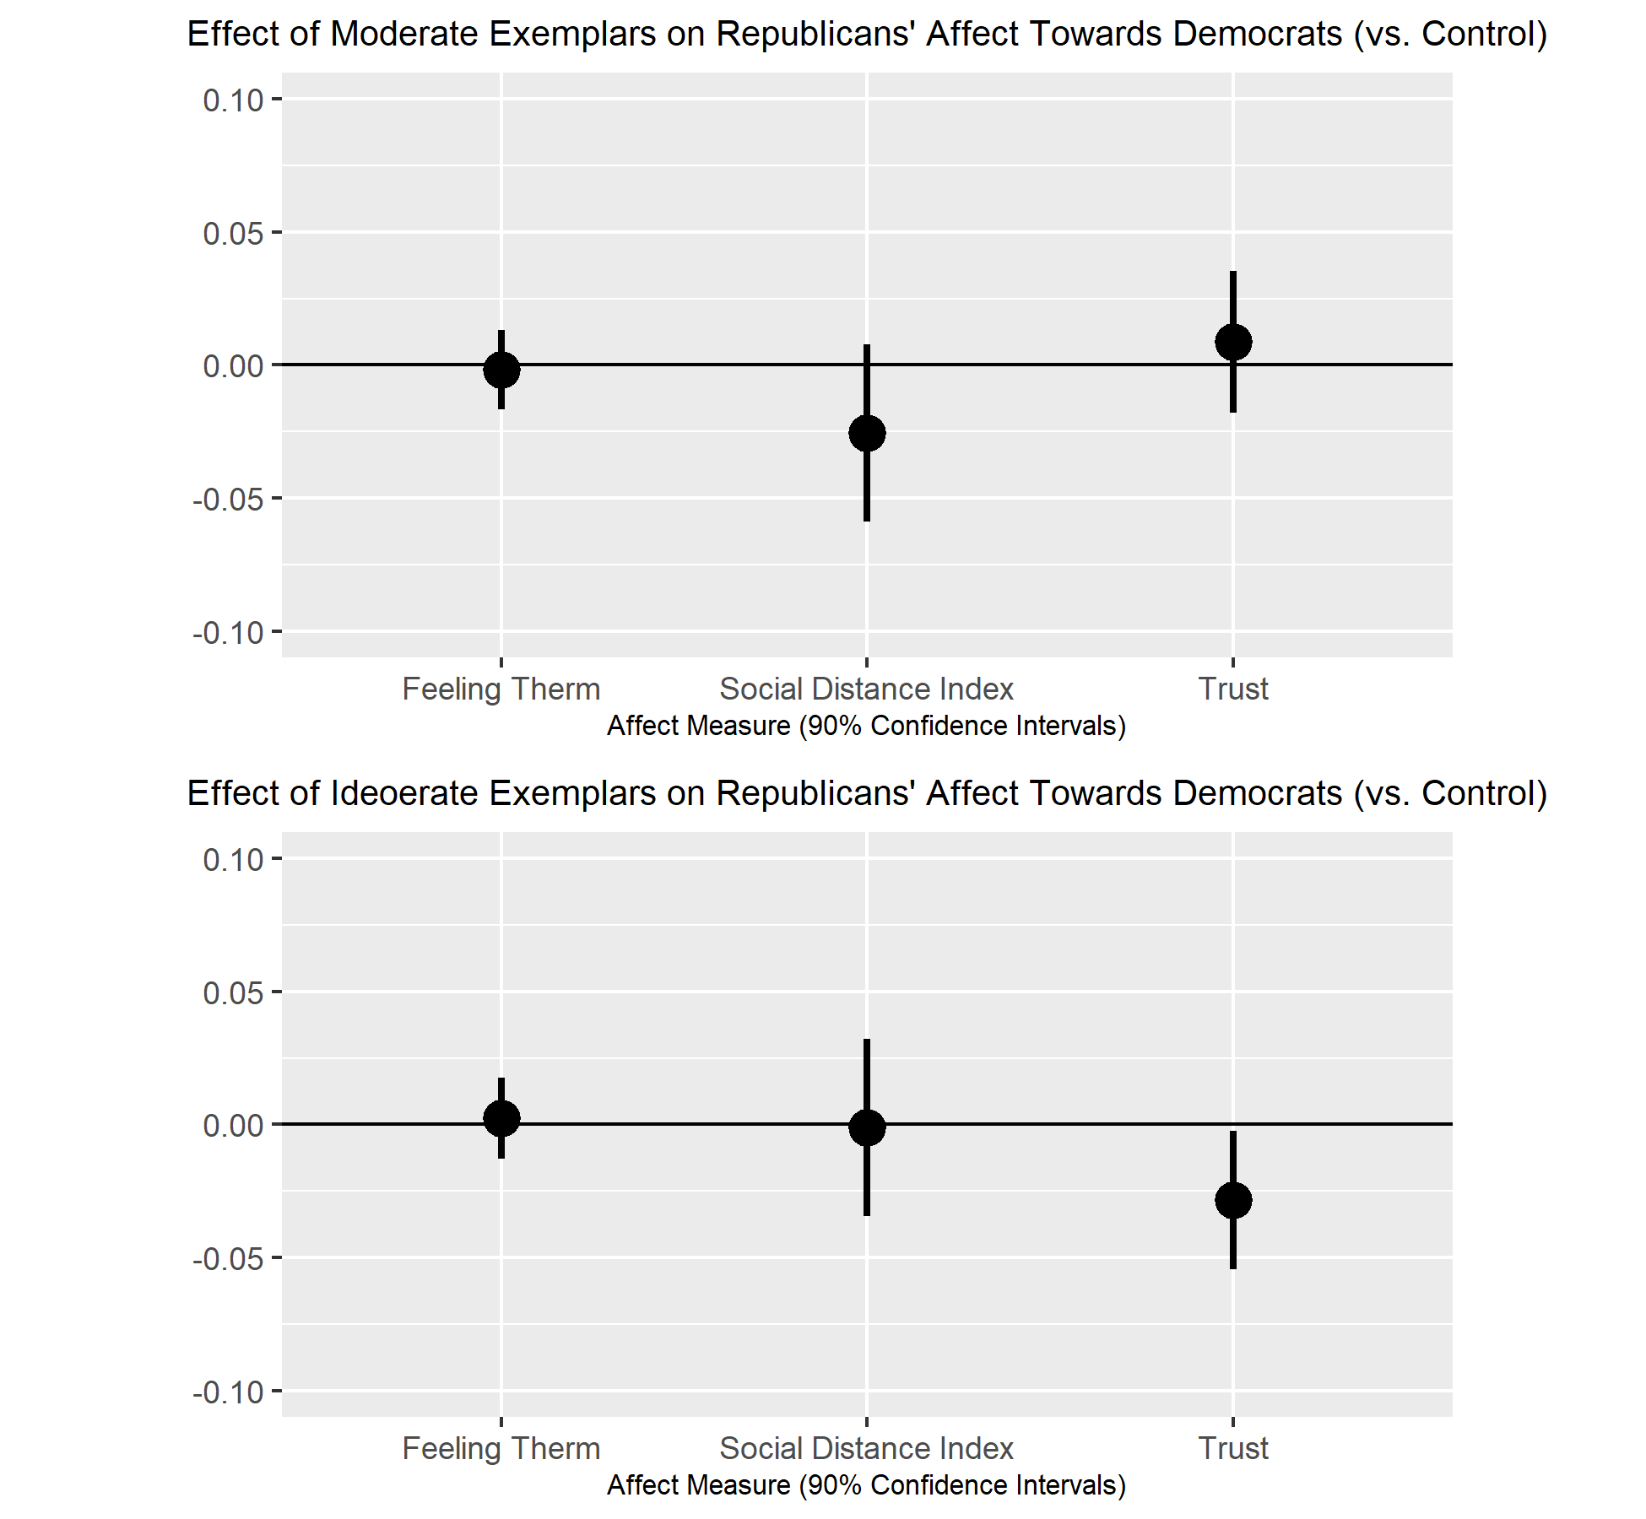
Figure 5: Effect of Dem Exemplars vs. Control on Rep Affect Towards Dems
Exemplars and Out-Party Affect
The second set of hypotheses predicted that moderate exemplars would improve affect towards the out-party. Figure 4a shows the effect of moderate Democratic exemplars on Republican affect towards Democrats – we rescale all measures to run between -1 and 1. The effects on the normalized feeling thermometer (p = .375, d = .02, d _{Reps/Inds} = .88) and the index of social distance measures (p = .190, d = .06, d _{Reps/Inds} = .24) are in the opposite of the expected direction, though neither is statistically significant and both are substantively small, especially relative to the benchmark of the difference between all Republicans and true independents in the sample. The effect on trust is in the expected direction and statistically significant (p = .01, d = .16, d _{Reps/Inds} = .46) and substantively of a similar magnitude as the effects on perceived issue positions, roughly one third of the difference between all Republicans and true independents in the sample.
Figure 4b shows the effect of moderate exemplars on Democratic affect towards Republicans. Here the effect on the out-party feeling thermometer is in the expected direction, but essentially zero (p = .46, d = .01, d _{Dems/Inds} = .93). The effect on trust (p = .031, d = .11, d _{Dems/Inds} = .39) and social distance (p = .063, d = .14, d _{Dems/Inds} = .35) are in the expected direction and statistically significant or marginally so. The magnitude of these effects is similar to other the other effects found here, again roughly one-third the size of the difference between all Democrats and all true independents in the sample.
As with H1, we next evaluate whether the observed effects is the result of participants in the moderate exemplar condition increasing their affect towards the out-party or participants in the liberal/conservative exemplar conditions reducing their affect towards the out-party. For Republicans’ preferences for social distance form Democrats (Figure 5), unexpected worsening in the moderate relative to the conservative condition is the result of the moderate condition decreasing affect relative to the control (p = .103, d = .14, d _{Reps/Inds} = .24), as the conservative condition has a negligible effect (p = .476, d = .01, d _{Reps/Inds} = .24), though neither effect is statistically significant. For trust, the observed effect appears primarily to be the effect of conservative exemplars reducing trust relative to the control (p = .037, d = .15, d _{Reps/Inds} = .46); moderate exemplars improved trust relative the control (p = .294, d = .05, d _{Reps/Inds} = .46), though this effect is not significantly significant. Effects on the feeling thermometer of both moderate (p = .422, d = .01, d _{Reps/Inds} = .88) and conservative exemplar conditions are negligible (p = .401, d = .02, d _{Reps/Inds} = .88).
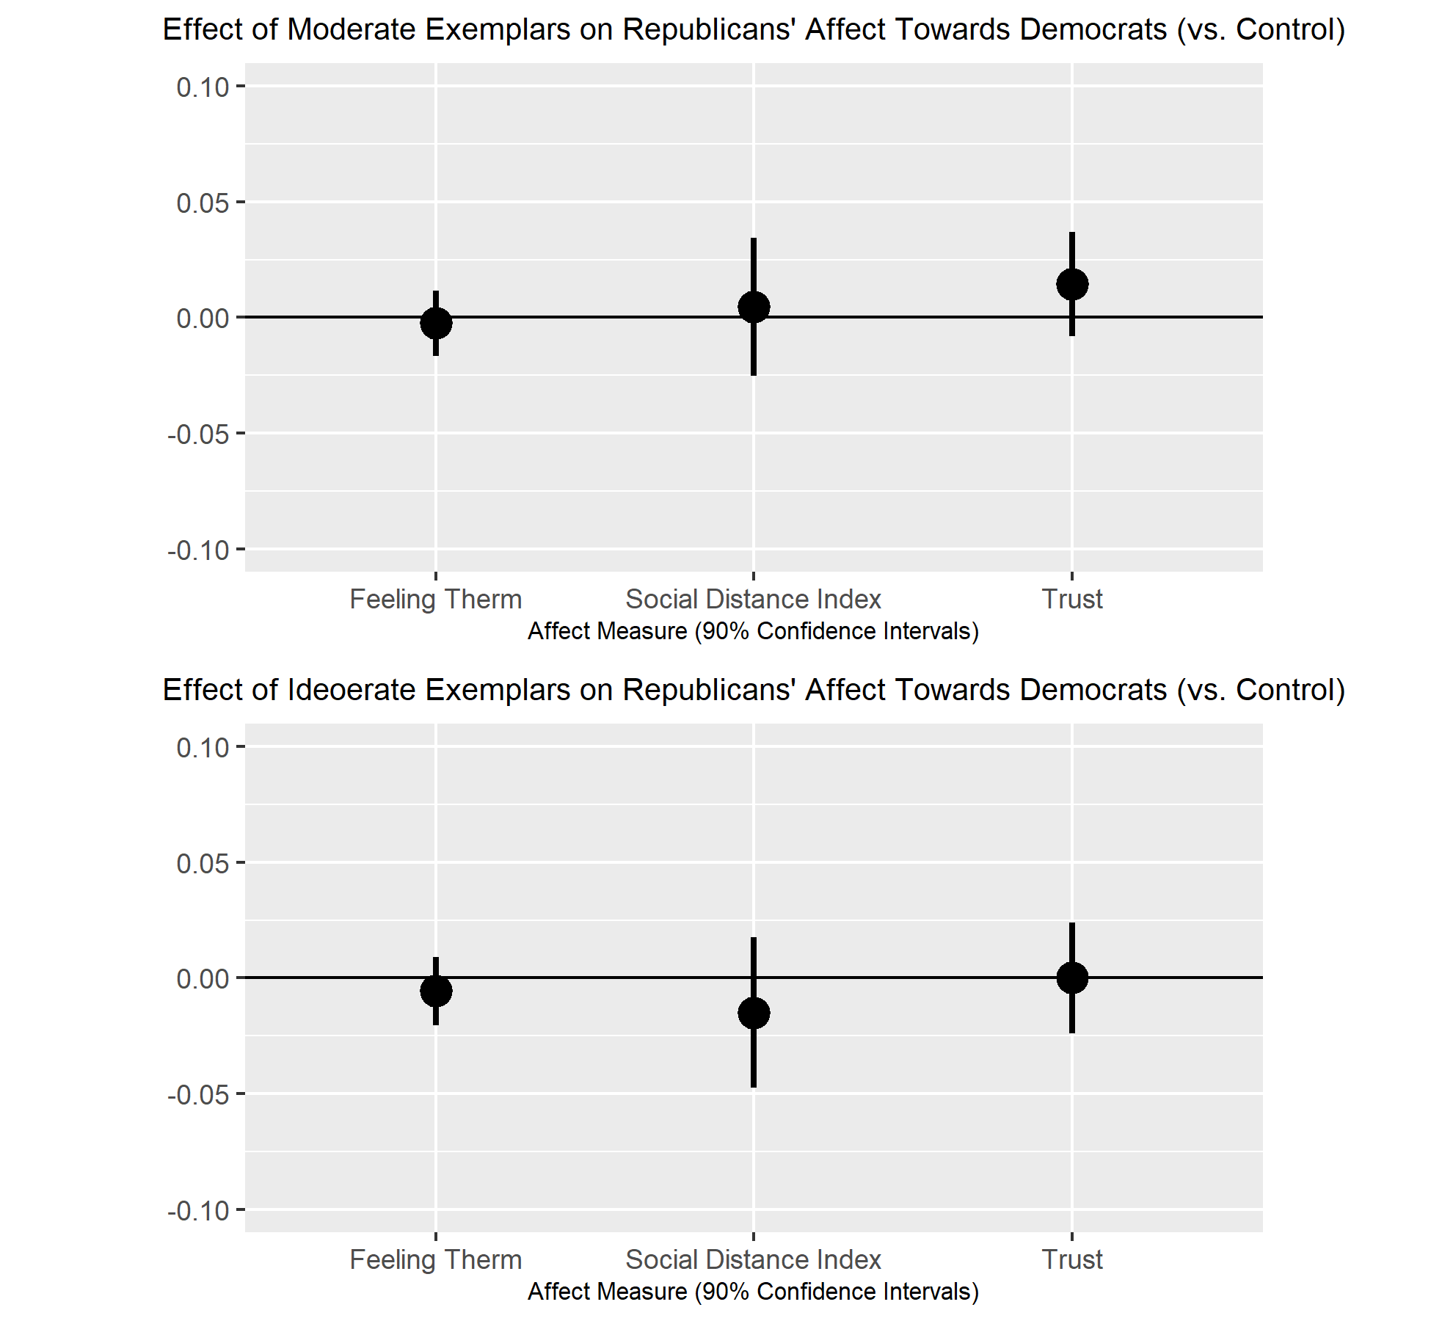
Figure 6: Effect of Rep Exemplars vs. Control on Dem Affect Towards Reps
The positive effect of moderate exemplars relative to conservative exemplars on Democrats’ affect towards Republicans appears to be the result of both moderate exemplars improving affect and conservative exemplars reducing affect, though none of the effects were statistically significant (Figure 6). Moderate exemplars had a positive but negligible effect on the social distance index (p = .401, d = .02, d _{Dems/Inds} = .35) while conservative exemplars had a more substantial, though still statistically insignificant, negative effect on the social distance measure (p = .224, d = .06, d _{Dems/Inds} = .35). The reverse was true for the measure of trust, where we find a positive but statistically insignificant effect of moderate exemplars (p = .148, d = .07, d _{Dems/Inds} = .39) but a negligible effect of conservative exemplars (p = .500, d = <.001, d _{Dems/Inds} = .39). Neither moderate (p = .383, d = .02, d _{Dems/Inds} = .93), nor negative exemplars (p = .264, d = .05, d _{Dems/Inds} = .93) had a meaningful effect on Democrats’ feeling thermometer for Republicans.
Overall, we find some evidence that moderate exemplars improve affect towards the out-party. Relative to ideological exemplars, moderate exemplars have a meaningful positive effect on three of six measures of affect; on two of these measures the effect was statistically significant at conventional levels, on the third it was nearly so. On one measure, Republicans’ preferences for social distance from Democrats, the effect was in the opposite direction, but did not approach statistical significance. There were no meaningful effects on the feeling thermometer of any of the experimental treatments. Comparing the treatment conditions to the control see no consistent pattern of results suggesting that these effects were the result of moderate exemplars improving affect or ideological exemplars reducing affect.

Conclusion
An extensive literature demonstrates the positive effect counter-stereotypical exemplars can have on stereotypes of and affect towards out-groups, particularly racial out-groups. This literature builds on exemplar-based theories of stereotypes (Kahneman and Miller 1986, Smith and Zarate 1992, Garcia-Marques et al. 2006), which argue that stereotypes are not stable, easily retrievable mental objects, but are instead constructed from individual exemplars stored in memory. Stereotypes are thus variable, as their content will depend on which exemplars are in memory and how salient each is at the moment the stereotype is constructed. Accordingly, we would expect exposure to counter-stereotypical exemplars to change stereotype content and with it out-group affect, as these counter-stereotypical exemplars are incorporated into the stereotype and also increase the salience of other counter-stereotypical exemplars stored in memory. Indeed, while there is disagreement about the magnitude of this effect (compare Dasgupta and Greenwald [2001] to Joy-Gaba and Nosek [2010]) and whether it affects implicit or explicit attitudes (compare Joy-Gaba and Nosek [2010] and Mastro and Tukachinsky [2011]), an extensive literature in psychology and communications demonstrates some version of this effect, primarily with racial out-groups.
This paper attempts to replicate the standard paradigm in this literature using partisan out-groups. To do so we present experimental participants with either ideologically stereotypical or counter-stereotypical out-party members of Congress. The results are generally consistent with theoretical expectations. We find a moderating effect of ideologically counter-stereotypical exemplars on most measures of stereotyping of out-party policy views, though we find a negligible effect on the perceived out-party position on taxes, and a negligible effect for Democrats’ view of Republicans’ general ideology. A simple explanation of this finding is that the profiles of members of Congress tended to feature more discussion of social and cultural issues than of economic issues. This design decision was made out of a desire to draft profiles that cast members as stereotypical or counter-stereotypical in as natural a way as possible by highlighting issues and actions that were most prominent in their biographies; additionally, we expected to analyze the three issues as an additive index, but did not do so because of low scale reliability. Future work should pay more attention to the match between the specific content of the exemplar descriptions and the measures of ideology.
Evidence of an effect on out-party affect is also generally in the expected direction, though somewhat more equivocal. Comparing ideologically counter-stereotypical to stereotypical exemplars, we find strong evidence of a positive effect on trust in the out-party, mixed evidence on preferences for social distance from the out-party, and a negligible effect on out-party feeling thermometer. It is perhaps not surprising that the strongest effects were found on the most elite-focused measure of affect; while the trust questions do not specifically mention members of Congress, their wording suggests that they are about Democrats or Republicans who are in a position to make policy or take government actions.
Several mechanisms have been proposed for how changes in the media environment might be connected to the rapid increase in affective polarization. These explanations tend to focus on biased information contained in the media – exposure to the arguments of one side, either through selective exposure made easier by the rise of partisan media or through biased assimilation of information. These results suggest a different mechanism: Changes in the people that are depicted as exemplars of the two parties. By more extreme or more moderate exemplars as the “face” of two parties, media outlets can change the stereotypes individuals hold about the parties and the affect they feel towards them. Either in response to genuine elite polarization, or as a result of different market incentives faced by new media outlets, change in media content may play an important role in Americans’ increasing antipathy towards the other party.
While we intended this study as a conceptual replication of the literature initiated by Dasgupta and Greenwald (2001), we deviate from the standard paradigm in this literature in three ways that may have muted the effects of these treatments. First, most previous studies in the literature use well-known, well-liked out-group exemplars, such as historical figures (e.g. Martin Luther King in Dasgupta and Greenwald [2001]) or celebrities (e.g. Jimmy Smits in Mastro and Tukachinsky [2011]). We instead used relatively anonymous members of Congress for the simple reason that we had a hard time coming up with out-party exemplars that we expected to be well-known, well-liked, and seen as representative of their contemporary parties. Second, many of the studies in this literature treat subjects with oppositely valanced out-group and in-group exemplars. For example, Dasgupta and Greenwald (2002) show participants in the pro-black condition liked black exemplars and disliked white exemplars while participants in the pro-white condition saw disliked black exemplars and liked white exemplars; Joy-Gaba and Nosek (2010) suggest that much of their observed effect might be because of in-group derogation, not increased out-group approval. We aimed to discover the effect of counter-stereotypical out-party exemplars by themselves, but we suspect that pairing counter-stereotypical out-party exemplars with disliked in-party exemplars would further improve out-party affect. Finally, most studies in this literature seek to make the exemplars’ out-group status salient by forcing participants to correctly identify the exemplars’ group before proceeding. Forcing participants to explicitly identify each exemplar as a Democrat or Republican might have strengthen the observed effects.
References
Ahler, Douglas J., and Gaurav Sood. 2018. “The Parties in Our Heads: Misperceptions about Party Composition and Their Consequences.” The Journal of Politics 80(3): 964–81.

Arceneaux, Kevin, and Martin Johnson. 2013. Changing Minds or Changing Channels?: Partisan News in an Age of Choice. Chicago ; London: The University of Chicago Press.

Baum, Matthew A., and Tim Groeling. 2008. “New Media and the Polarization of American Political Discourse.” Political Communication 25(4): 345–65.

Berry, Jeffrey M., and Sarah Sobieraj. 2016. The Outrage Industry: Political Opinion Media and the New Incivility. Reprint edition. Oxford University Press.

Brosius, Hans-Bernd. 2003. “Exemplars in the News: A Theory of the Effects of Political Communication.” In Communication and Emotion: Essays in Honor of Dolf Zillmann, eds. Jennings Bryant, David R. Roskos-Ewoldsen, and Joanne Cantor. Mahwah, NJ: Routledge, 179=194.

Carpenter, Thomas P. et al. 2019. “Survey-Software Implicit Association Tests: A Methodological and Empirical Analysis.” Behavior Research Methods 51(5): 2194–2208.

Columb, Corey, and E. Ashby Plant. 2016. “The Obama Effect Six Years Later: The Effect of Exposure to Obama on Implicit Anti-Black Evaluative Bias and Implicit Racial Stereotyping.” Social Cognition 34(6): 523–43.

Dasgupta, Nilanjana, and Anthony G. Greenwald. 2001. “On the Malleability of Automatic Attitudes: Combating Automatic Prejudice with Images of Admired and Disliked Individuals.” Journal of Personality and Social Psychology 81(5): 800–814.

Dasgupta, Nilanjana, and Shaki Asgari. 2004. “Seeing Is Believing: Exposure to Counterstereotypic Women Leaders and Its Effect on the Malleability of Automatic Gender Stereotyping.” Journal of Experimental Social Psychology 40(5): 642–58.

Dasgupta, Nilanjana, and Luis M. Rivera. 2008. “When Social Context Matters: The Influence of Long–Term Contact and Short–Term Exposure to Admired Outgroup Members on Implicit Attitudes and Behavioral Intentions.” Social Cognition 26(1): 112–23.

Dixon, Travis L. 2008. “Crime News and Racialized Beliefs: Understanding the Relationship Between Local News Viewing and Perceptions of African Americans and Crime.” Journal of Communication 58(1): 106–25.

Entman, Robert M., and Andrew Rojecki. 2000. The Black Image in the White Mind: Media and Race in America. Chicago: University of Chicago Press.

Fiorina, Morris P., and Samuel J. Abrams. 2008. “Political Polarization in the American Public.” Annual Review of Political Science 11(1): 563–88.

Fiorina, Morris P., Samuel J. Abrams, and Jeremy Pope. 2011. Culture War?: The Myth of a Polarized America. 3rd ed.. Boston, MA, Boston: Longman.

Garcia-Marques, Leonel et al. 2017. “Cognitive Malleability and the Wisdom of Independent Aggregation.” Psychological Inquiry 28(4): 262–67.

Garcia-Marques, Leonel, A. Sofia C. Santos, and Diane M. Mackie. 2006. “Stereotypes: Static Abstractions or Dynamic Knowledge Structures?” Journal of Personality and Social Psychology 91(5): 814–31.

Gentzkow, Matthew, and Jesse M. Shapiro. 2011. “Ideological Segregation Online and Offline.” The Quarterly Journal of Economics 126(4): 1799–1839.

Gilens, Martin. 1999. Why Americans Hate Welfare: Race, Media, and the Politics of Antipoverty Policy. Chicago, Ill.: University of Chicago Press.

Goldman, Seth K. 2012. “Effects of the 2008 Obama Presidential Campaign on White Racial Prejudice.” Public Opinion Quarterly 76(4): 663–87.

Goldman, Seth K., and Diana Carole Mutz. 2014. The Obama Effect: How the 2008 Campaign Changed White Racial Attitudes. New York, New York: Russell Sage Foundation.

Goldman, Seth K., and Daniel J. Hopkins. 2019. “When Can Exemplars Shape White Racial Attitudes? Evidence from the 2012 U.S. Presidential Campaign.” International Journal of Public Opinion Research 31(4): 649–68.

Harden, Jeffrey J., Anand E. Sokhey, and Katherine L. Runge. 2019. “Accounting for Noncompliance in Survey Experiments.” Journal of Experimental Political Science 6(3): 199–202.

Iyengar, Shanto, Gaurav Sood, and Yphtach Lelkes. 2012. “Affect, Not Ideology: A Social Identity Perspective on Polarization.” Public Opinion Quarterly 76(3): 405–31.

Iyengar, Shanto, and Sean J. Westwood. 2015. “Fear and Loathing across Party Lines: New Evidence on Group Polarization.” American Journal of Political Science 59(3): 690–707.

Iyengar, Shanto et al. 2019. “The Origins and Consequences of Affective Polarization in the United States.” Annual Review of Political Science 22(1): 129–46.

Joy-Gaba, Jennifer A., and Brian A. Nosek. 2010. “The Surprisingly Limited Malleability of Implicit Racial Evaluations.” Social Psychology 41(3): 137.

Kahneman, Daniel, and Dale T. Miller. 1986. “Norm Theory: Comparing Reality to Its Alternatives.” Psychological Review 93(2): 136–53.

Kerevel, Yann P., and Lonna Rae Atkeson. 2015. “Reducing Stereotypes of Female Political Leaders in Mexico.” Political Research Quarterly 68(4): 732–44.

Klar, Samara, Thomas Leeper, and Joshua Robison. Forthcoming. “Studying Identities with Experiments: Weighing the Risk of Posttreatment Bias Against Priming Effects.” Journal of Experimental Political Science.

Lelkes, Yphtach, Gaurav Sood, and Shanto Iyengar. 2017. “The Hostile Audience: The Effect of Access to Broadband Internet on Partisan Affect.” American Journal of Political Science 61(1): 5–20.

Levendusky, Matthew S. 2013. “Why Do Partisan Media Polarize Viewers?” American Journal of Political Science 57(3): 611–23.

Levendusky, Matthew S., and Neil Malhotra. 2016a. “Does Media Coverage of Partisan Polarization Affect Political Attitudes?” Political Communication 33(2): 283–301.

Levendusky, Matthew S., and Neil Malhotra. 2016b. “(Mis)Perceptions of Partisan Polarization in the American Public.” Public Opinion Quarterly 80(S1): 378–91.

Lippmann, Walter. 1922. Public Opinion. New York: Macmillan, Harcourt, Brace.

Mason, Lilliana. 2018. Uncivil Agreement: How Politics Became Our Identity. Chicago, Illinois: University of Chicago Press.

Mason, Lilliana, and Julie Wronski. 2018. “One Tribe to Bind Them All: How Our Social Group Attachments Strengthen Partisanship.” Political Psychology 39(S1): 257–77.

Mastro, Dana, and Riva Tukachinsky. 2011. “The Influence of Exemplar versus Prototype-Based Media Primes on Racial/Ethnic Evaluations.” Journal of Communication 61(5): 916–37.

Mares, Marie-Louise. Forthcoming. “Mostly Positive: Effects of Reminding White Teens about Latino and Asian American Celebrities.” Media Psychology.

Montgomery, Jacob M., Brendan Nyhan, and Michelle Torres. 2018. “How Conditioning on Posttreatment Variables Can Ruin Your Experiment and What to Do about It.” American Journal of Political Science 62(3): 760–75.

Mutz, Diana C. 2007. “How the Mass Media Divide Us.” In Red and Blue Nation?: Characteristics and Causes of America’s Polarized Politics, eds. Pietro S. Nivola and David W. Brady. Brookings Institution Press, 223–62.

Myers, C. Daniel. 2020. “Measuring Partisan Stereotypes Using a Conjoint Experiment.” University of Minnesota Working Paper.

Nosek, Brian A. et al. 2014. “Understanding and Using the Brief Implicit Association Test: Recommended Scoring Procedures.” PLOS ONE 9(12): e110938.

Pasek, Josh et al. 2014. “Attitudes Toward Blacks in the Obama EraChanging Distributions and Impacts on Job Approval and Electoral Choice, 2008–2012.” Public Opinion Quarterly 78(S1): 276–302.

Pinkston, Kevin. 2015. “The Black-White Malleability Gap in Implicit Racial Evaluations: A Nationally Representative Study.” The Journal of Social Psychology 155(3): 189–203.

Power, J. Gerard, Sheila T. Murphy, and Gail Coover. 1996. “Priming Prejudice: How Stereotypes and Counter-Stereotypes Influence Attribution of Responsibility and Credibility among Ingroups and Outgroups.” Human Communication Research 23(1): 36–58.

Prior, Markus. 2013. “Media and Political Polarization.” Annual Review of Political Science 16(1): 101–27.

Ramasubramanian, Srividya. 2007. “Media-Based Strategies to Reduce Racial Stereotypes Activated by News Stories.” Journalism & Mass Communication Quarterly 84(2): 249–64.

Ramasubramanian, Srividya. 2011. “The Impact of Stereotypical Versus Counterstereotypical Media Exemplars on Racial Attitudes, Causal Attributions, and Support for Affirmative Action.” Communication Research 38(4): 497–516.

Ramasubramanian, Srividya. 2015. “Using Celebrity News Stories to Effectively Reduce Racial/Ethnic Prejudice.” Journal of Social Issues 71(1): 123–38.

Ramasubramanian, Srividya, and Mary Beth Oliver. 2007. “Activating and Suppressing Hostile and Benevolent Racism: Evidence for Comparative Media Stereotyping.” Media Psychology 9(3): 623–46.

Rothschild, Jacob E., Adam J. Howat, Richard M. Shafranek, and Ethan C. Busby. 2019. “Pigeonholing Partisans: Stereotypes of Party Supporters and Partisan Polarization.” Political Behavior 41(2): 423–43.

Schmidt, Kathleen, and Brian A. Nosek. 2010. “Implicit (and Explicit) Racial Attitudes Barely Changed during Barack Obama’s Presidential Campaign and Early Presidency.” Journal of Experimental Social Psychology 46(2): 308–14.

Schmidt, Kathleen, and Jordan R. Axt. 2016. “Implicit and Explicit Attitudes Toward African Americans and Barack Obama Did Not Substantively Change During Obama’s Presidency.” Social Cognition 34(6): 559–88.

Smith, Eliot R., and Michael A. Zarate. 1992. “Exemplar-Based Model of Social Judgment.” Psychological Review 99(1): 3–21.

Tukachinsky, Riva, Dana Mastro, and Moran Yarchi. 2015. “Documenting Portrayals of Race/Ethnicity on Primetime Television over a 20-Year Span and Their Association with National-Level Racial/Ethnic Attitudes.” Journal of Social Issues 71(1): 17–38.

Valentino, Nicholas A. 1999. “Crime News and the Priming of Racial Attitudes During Evaluations of the President.” The Public Opinion Quarterly 63(3): 293–320.

Valentino, Nicholas A., and Kirill Zhirkov. 2018. “Blue Is Black and Red Is White? Affective Polarization and the Racialized Schemas of U.S. Party Coalitions.” University of Michigan Working Paper.

Thanks to Chris Federico and the participants in the University of Minnesota American Politics Colloquium for feedback on this paper. Thanks to Lillian Norman for research assistance with this study. This research was funded by the Grant in Aid of Research, Artistry, and Scholarship program of the University of Minnesota Office of the Vice President for Research. All errors or omissions are, of course, my own.
Dasgupta and Greenwald (2001) report standardized effect sizes in the range of .82 and .89 standard deviations in experiments with 48 and 21 subjects, respectively. Joy-Gaba and Nosek (2010) report effect sizes of .17, .14, .03, .16, and .11 standard deviations with samples of 796, 1,191, 1,081, 95, and 77, respectively.
Goldman and Mutz (2014) argue that this is because media coverage and public attention to Obama fell after the campaign period.
Consider Barack Obamas (in)famous quote “if you watch Fox News, you are living on a different planet than you are if you ... listen to NPR.” (; for different coverage that demonstrates Obama’s point, see Flood 2018)
We also collected data on implicit affect using a partisan Brief Implicit Association Test, modeled on that in Iyengar and Westwood (2015), but are still analyzing this data.
Lucid is an online aggregator of survey respondents that offers demographically representative samples via quota sampling. Coppock and McClellan (2019) show that respondents from Lucid largely match ANES demographic and behavioral benchmarks; they also replicate several prominent experimental findings from probability samples using Lucid subjects
Available at http://users.cla.umn.edu/~cdmyers/PartisanExemplarsDGReplicationSPSAAppendix12312019.docx.
This sample size represents a deviation from our Pre-Analysis Plan, which called for recruiting 1,733 respondents. This sample size was determined by the number of respondents necessary to achieve .8 power to detect a difference of means of Cohen’s d = .35 on the partisan BIAT. Since the BIAT can only be completed by respondents using devices with keyboards, we expected 866 of the 1,733 responses to complete the BIAT, of whom 760 would provide useable responses. However, the percentage of respondents who completed the BIAT was, in fact, closer to 25%, partially because a higher percentage of respondents than expected used mobile devices and partially because a significant percentage of those with keyboards had difficulty with the BIAT. To achieve the pre-specified power for the BIAT, we recruited an additional 1,212 respondents. Lucid, in its inscrutable ways, seems to have provided an additional 222 respondents for free.
We know of no work that evaluates the reliability of Lucid-supplied demographics. In the pretest (n = 147) we asked the traditional ANES 7-point question and compared this to the Lucid-supplied party ID. For 83.7% of respondents, response to this question matched the Lucid-supplied party ID question exactly; for an additional 10.9% of respondents the party matched, but strength of partisanship was different. Based on this, we are fairly comfortable relying on the Lucid-supplied measurement, particularly as this provides us with a pre-treatment measure (Montgomery et al. 2018) that does not run the risk of priming partisanship (Klar et al. 2019).
These questions are “Generally speaking, how interested are you in politics?” with response options Extremely interested (1), Very interested (2), Somewhat interested (3), Slightly interested (4), Not at all interested (5) and “How much of the time would you say you follow what's going on in government and public affairs?” with response options Most of the time (1), Some of the time (2), Only now and then (3), and Hardly at all (4).
These items asked “How much of the time do you think you can trust <Republicans/Democrats> to do what is right for the country?” with response options “Almost always” (5), “Most of the time” (4), “About half the time” (3), “Once in a while” (2), “Almost never” (1) and “Do you trust Republicans to work for the interests of average Americans?” with response options “Definitely yes” (4), “Probably yes” (3), “Probably not” (2), and “Definitely not” (1).
These are “How comfortable are you having close personal friends who are <Republicans/Democrats>?” and “How comfortable are you having neighbors on your street who are <Republicans/Democrats>?”, both with response options “Extremely comfortable” (4), “Somewhat comfortable” (3), “Not too comfortable” (2), and “Not at all comfortable” (1), and “Suppose a son or daughter of yours was getting married. How would you feel if he or she married a <Republican/Democrat>?” with response options “Not at all upset” (4), “Not too upset” (3), “Somewhat upset” (2), and “Extremely upset” (1).
Most studies in the psychological literature find no effect on explicit attitudes, but generally only use a single measure of explicit attitudes, generally a feeling thermometer. Our results suggest that the failure to find an effect on explicit attitudes might be the result of poor measurement.
11 of 14 profiles explicitly mentioned abortion, and the most frequently mentioned issues besides abortion were LGBTQ issues (nine profiles), gun control (seven profiles) and environmental issues (six profiles), especially climate change. In contrast, only three profiles explicitly mentioned taxes, and the only other economic issue mentioned by more than one profile were the minimum wage (three profiles), and Obamacare (three profiles).

